Networking Exercise 002 - Ping

Ping: tests weather my device can communicate with another computer, printer or a website
Packets: tiny pieces of information sent across a network
Ms: how fast the other device or website responded too your reply the smaller the number of ms the faster

Objective:
Check whether my laptop can communicate with a website over the internet.
Tools Used:
- Command Prompt (cmd)
- ping: tests and checks weather my device can communicate with another device on awebiste
Command Used:
ping google.com
What I observed:
- Google responded to my request.
- I could see the time it took for the response to return (ms).
- I could see packets sent and packets received.
What I learned:
- Ping tests whether my device can communicate with another device or website.
- A successful ping usually means I have an internet connection.
- Ping can help identify connectivity problems.
Skills demonstrated:
- Networking fundamentals
- Command Prompt usage
- Basic troubleshooting
- Connectivity testing
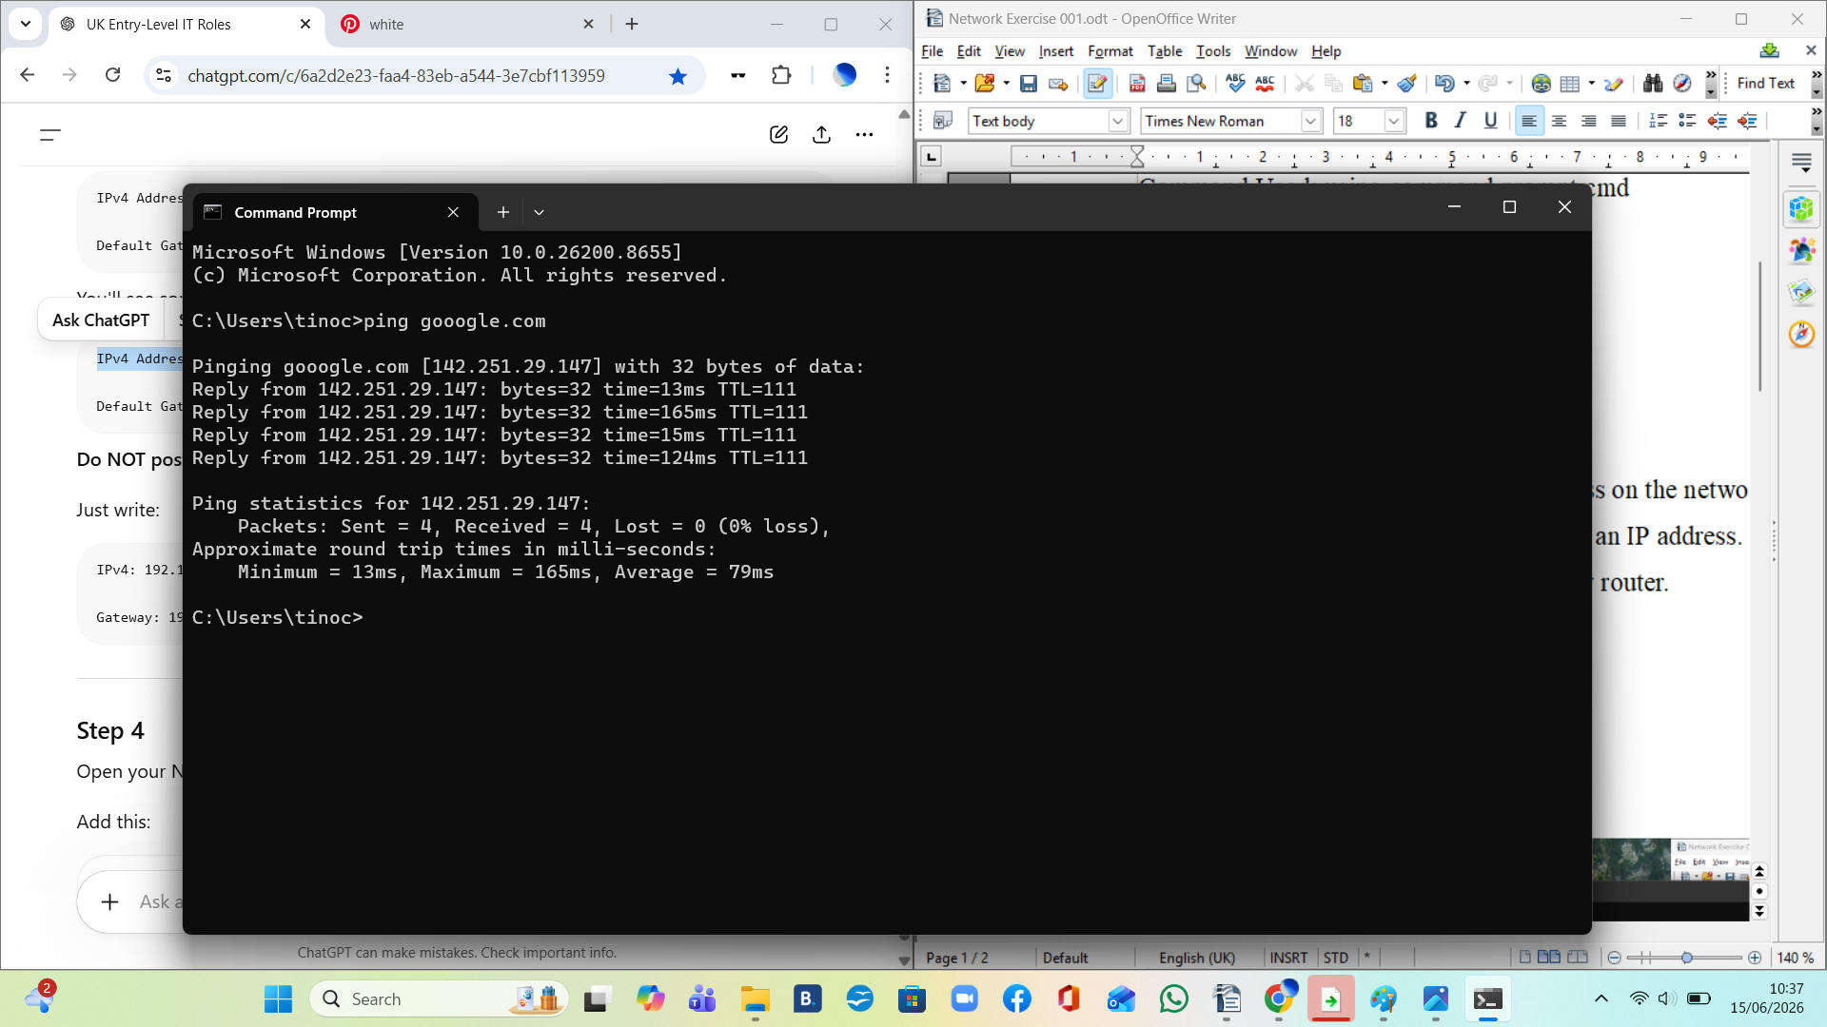
Investigations and testing

Difffertnt websites usallly have the same number of packet but diferent speeds youtube is faster than google perhaps because google use fot infotmation

ping -t google.com: Continuously tests communication with a website until you stop it. I would use it When a user says their internet keeps disconnecting.so If I see Request timed out or very high ms, the connection may be unstable.
